Configuring Network Interfaces (ifconfig, ip, nmcli)? Understanding DNS, DHCP, and Static IP Configuration? Firewall Management (iptables, firewalld, ufw)
Tasks
1.Use the ifconfig or ip command to display the current IP address and network interfaces on your Linux system, then take a screenshot of the output.
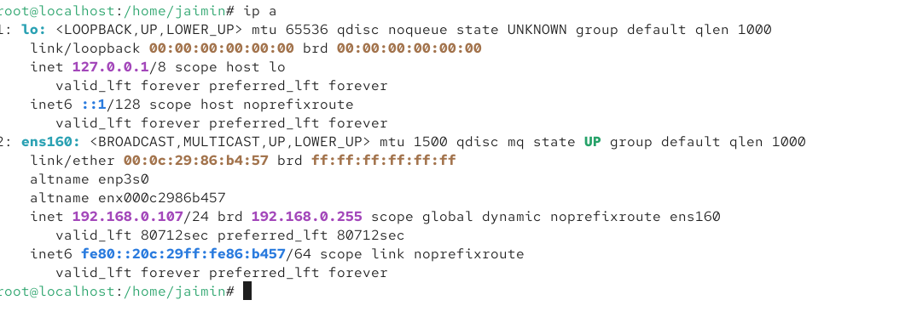
2.Configure a static IP address for your system using nmcli so that your device always gets the same IP (for example, 192.168.1.50/24 with gateway 192.168.1.1 and DNS 8.8.8.8).Hint: Use 'nmcli con mod' to set ipv4.addresses, ipv4.gateway, and ipv4.dns, then bring the connection down and up to apply changes.
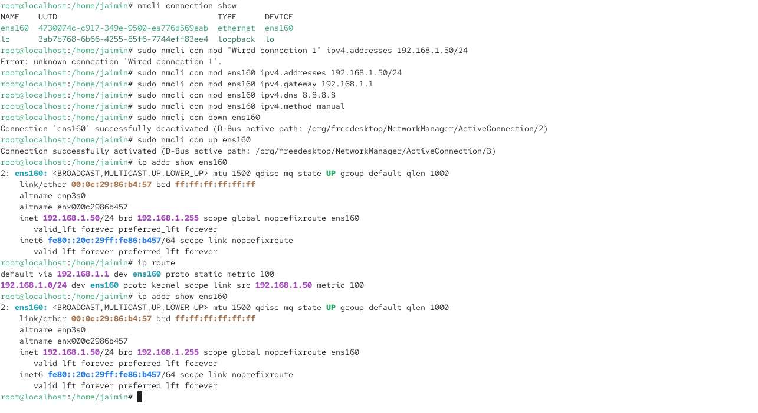

3.Explain in your own words the difference between DNS and DHCP, and give a real-world example of how each is used in an app like Zomato or Flipkart.
Difference Between DNS and DHCP
DNS (Domain Name System) and DHCP (Dynamic Host Configuration Protocol) are both important network services, but they perform different jobs. DNS is responsible for translating human-readable domain names into IP addresses that computers can understand. For example, when a user opens www.zomato.com, the device does not directly know the IP address of Zomato's server. DNS looks up the domain name and provides the corresponding IP address, allowing the device to connect to the correct server. DNS makes the Internet easier to use because users can remember names instead of complicated numerical IP addresses. DNS can also be used for other purposes, such as finding mail servers and different types of network services.
DHCP, on the other hand, is responsible for automatically providing network configuration information to devices when they connect to a network. This information can include an IP address, subnet mask, default gateway, and DNS server address. For example, when a mobile phone connects to Wi-Fi, it normally receives an IP address automatically from the DHCP server in the router. Without DHCP, users would have to manually configure the IP address and other network settings on every device, which would be inconvenient and could cause IP address conflicts.
Real-World Example Using Zomato
Consider a user opening the Zomato app on a mobile phone. First, when the phone connects to Wi-Fi or mobile data, DHCP can provide the device with the necessary network configuration, such as an IP address, gateway, and DNS server. This allows the phone to communicate with other devices and access the Internet. When the Zomato application needs to contact Zomato's backend servers, DNS helps translate the Zomato domain name into the appropriate server IP address. The phone can then establish a connection with Zomato's servers and request information such as restaurant details, menus, offers, and order status.
Simple Difference
In simple words, DHCP gives your device an identity on the network, while DNS helps your device find another computer or server by its name. DHCP is mainly used when a device joins a network and needs network settings, whereas DNS is used whenever a device needs to translate a domain name into an IP address.
Example:
DHCP → "Here is your phone's IP address: 192.168.1.20."
DNS → "The server for Zomato's domain is available at this IP address."
Therefore, both services are essential for applications like Zomato and Flipkart to work smoothly over the Internet. DHCP enables the user's device to communicate with the network, while DNS helps the device locate the application's servers.

4.Enable the firewall on your system using ufw, then allow incoming connections only on port 80 (HTTP) and block all others. Show the status output after applying these rules.

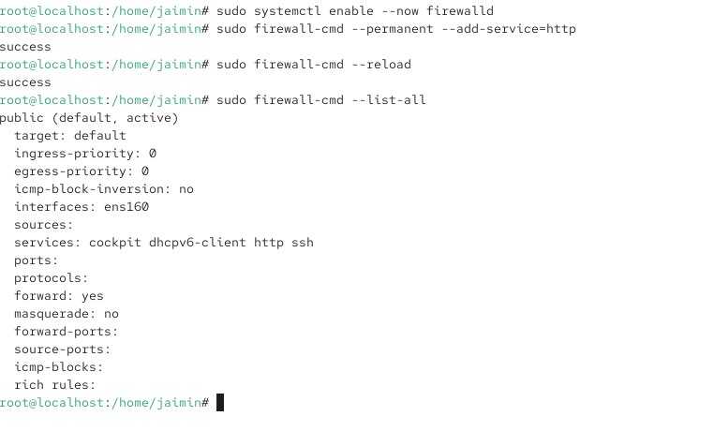
5.Use firewalld or iptables to temporarily block all outgoing traffic to a specific website (for example, www.spotify.com) and then verify that you cannot ping the site from your terminal.Hint:</strong> You may need to use the site's IP address instead of the domain name.
